KTS GOVT.DEGREE COLLEGE, RAYADURG,ANANTAPUR Dt.
NSS UNIT-I
NSS SPECIAL CAMP REPORT
Day-1:
A special camp of National Service Scheme at B.N Halli village commenced on this day under the leadership of C. Dodda Nagappa, Program Officer of National Service Scheme, Unit-I of KTS Government Degree College Rayadurg. On this occasion, College Principal Dr. R. Raghurama Murthy said that 6 NSS-special camps were held under the NSS wing of the college after he assuming as principal. Volunteers are suggested to do good service in B.N Halli as before and bring good name to the college. Program Officer C.Dodda Nagappa said that as part of the seven-day program, we will go ahead with a special service program every day like awareness programs on clean and green, prevention of Seasonal diseases, water management, air pollution & Global warming, utilization of right to vote, eradication of superstitions, etc.
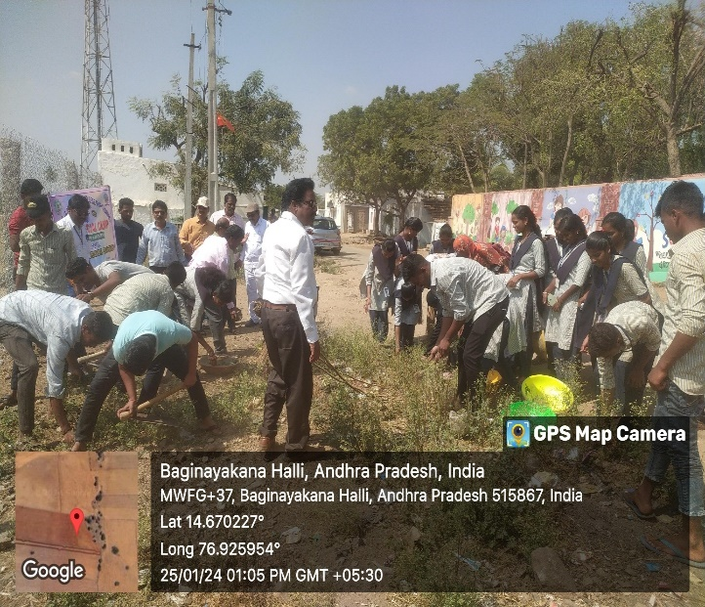
School Headmaster Nagaraju, Panchayat Secretary Shobha, NSS Program Officers D. Narayana, M. Ramakrishna, Lecturers Ravikumar, Babu, Radhakrishna, Prasad, Vijaya Kumar and volunteers participated in the program.
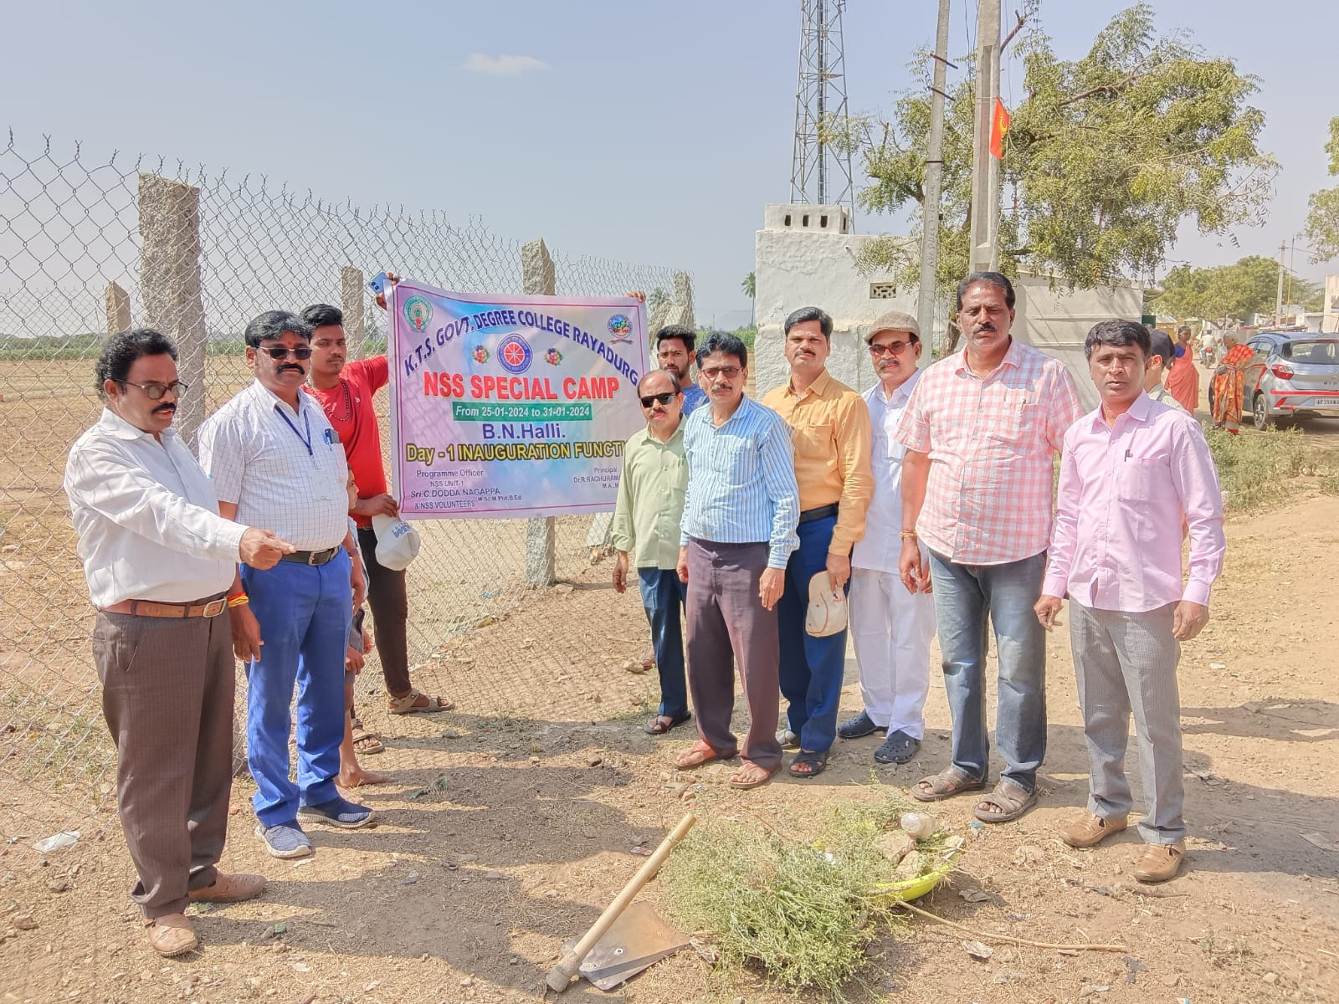
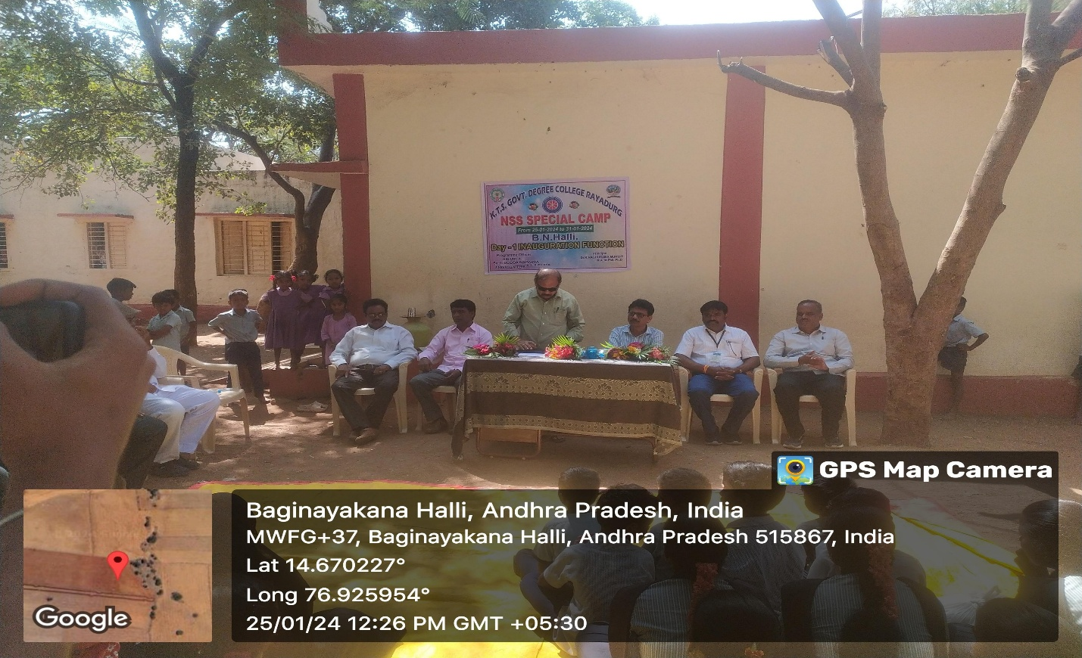
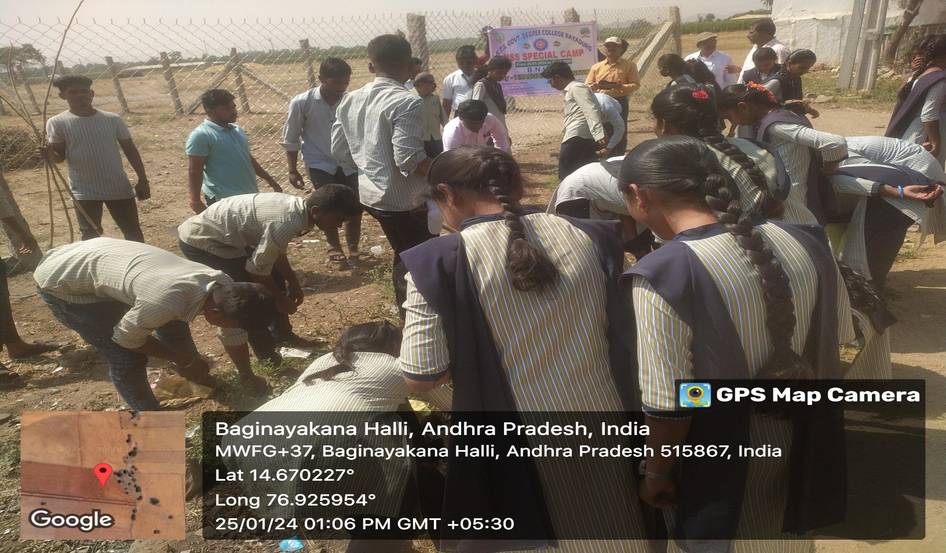
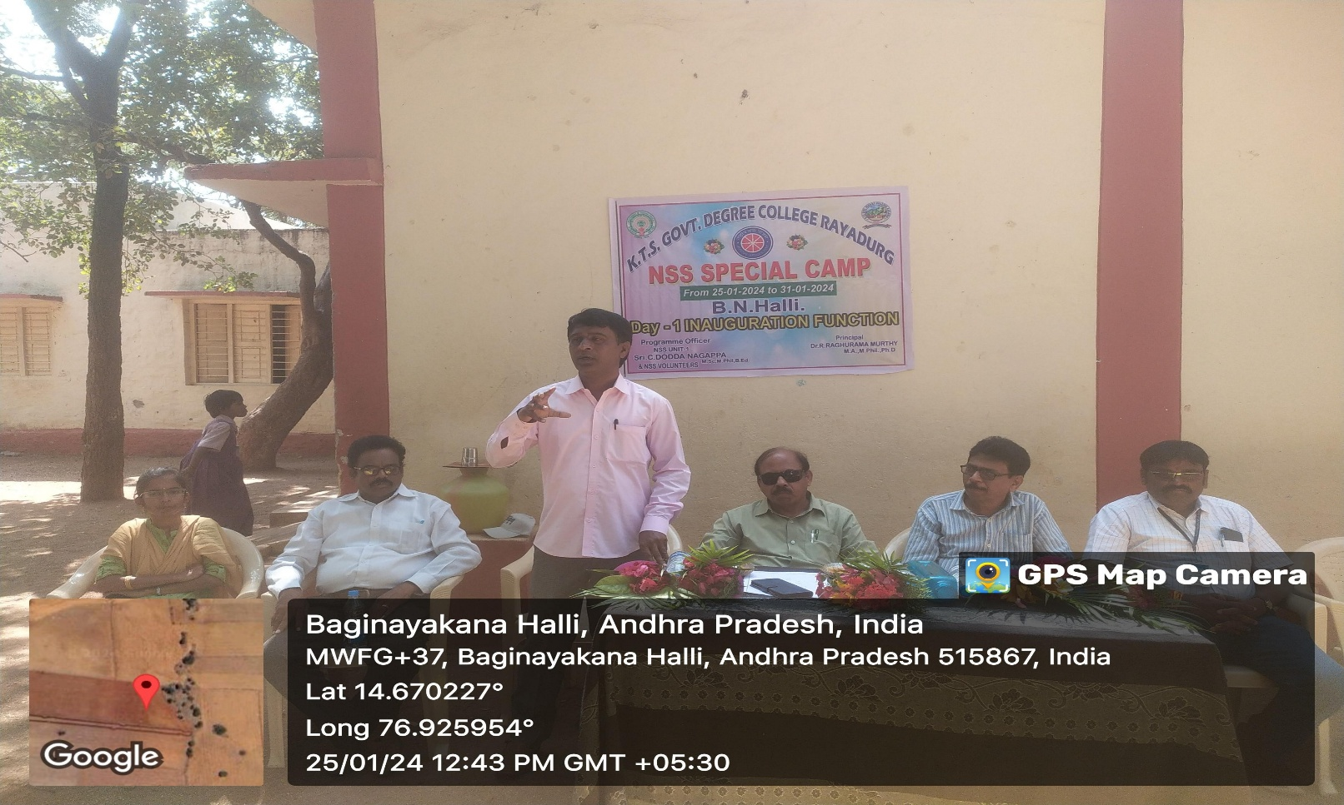
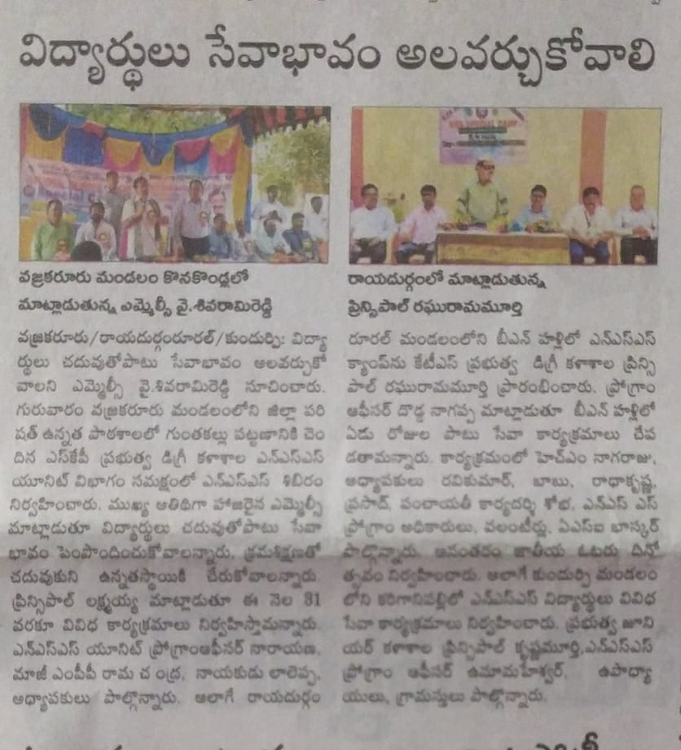
Day 2:
Swachh Bharat was organized as part of the second day program of National Service Scheme seven days special camp at B.N Halli village under the leadership of C. Dodda Nagappa, National Service Scheme, Unit 1 Program Officer of KTS Government Degree College. The volunteers removed waste materials, plastic covers and litter around the main road in the village. The main road has been swept and cleaned for a kilometer length. Mandal Primary School Headmaster Nagaraju and people congratulated the volunteers on this occasion. Later, as part of Swachh Bharat program, let's move forward by organizing a rally - towards cleanliness, let's keep the environment clean - let's get rid of diseases. The volunteers made people aware with slogans. Today the camp was visited by the College Lecturers Prasad, Mallikarjuna, Pal Raj, N.C.C. Coordinator Kiran. Mandal Primary School Headmaster Nagaraju and Netram Palli High School teacher Bhuvaneshwar visited and congratulated the volunteers along with Program Officer C.Dodda Nagappa and others.

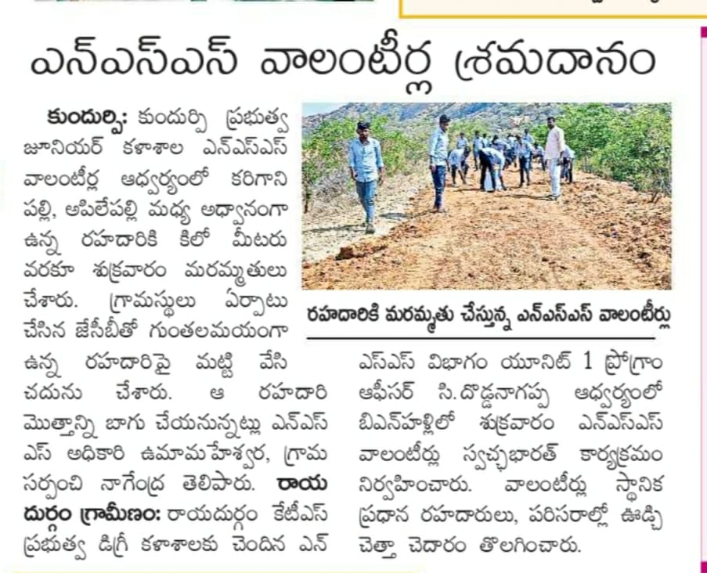
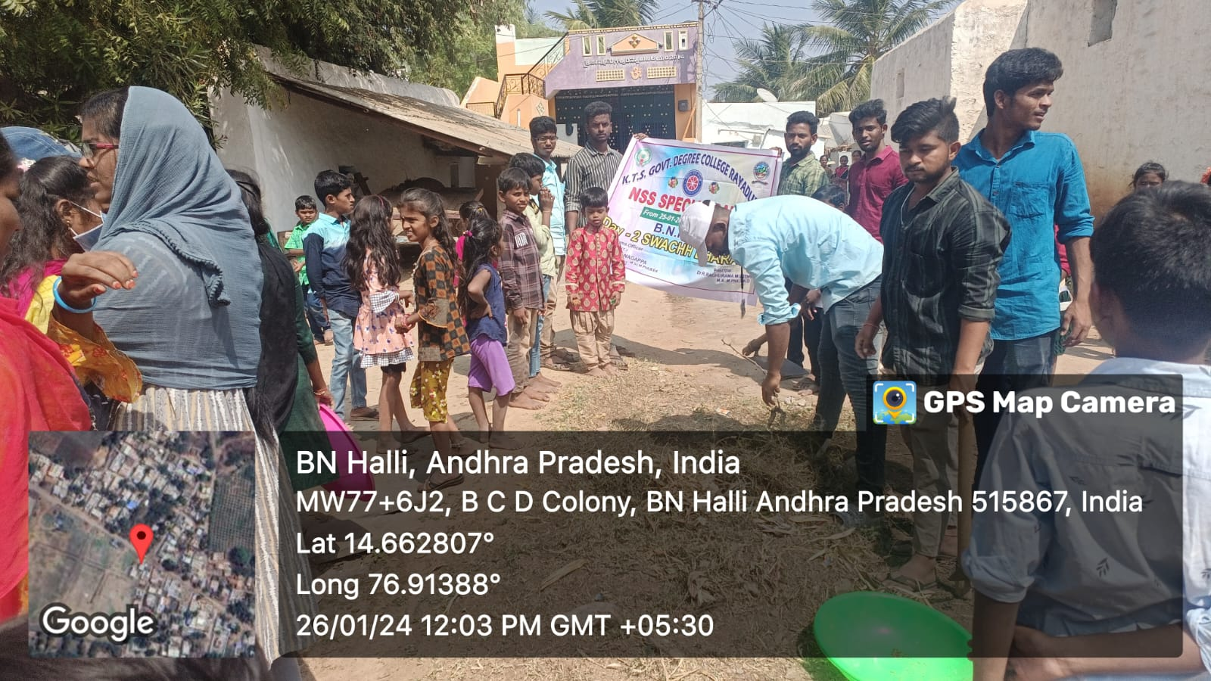

Day 3:
C. Dodda Nagappa, National Service Scheme, Unit-1 Program Officer of KTS Government Degree College .Conducted awareness programs about water management and Global warming in the village as part of the third day program of National Service Scheme seven days special camp in B.N Halli village. On this occasion, the volunteers went to every house and explained to the people about the increasing pollution in nature, about Global warming and rising temperature, and informed the need to grow trees. If trees are grown, the home will be comfortable and prosperous, water should be used properly and sparingly, and everyone should take the responsibility of growing water bodies. People say that we will surely grow trees.
Guaranteed. People appreciated the volunteers. Later, by organizing a rally, the volunteers made people aware with the slogans of let's grow trees - let's live coolly, if we grow trees - the generations will be good, growing trees - it's our responsibility, join hands to drain the water and grow silk and water. Today the camp was Visited by college faculty and N.S.S. Program Officers D. Narayana, M.Ramakrishna and village M.P.P. School Teachers and others congratulated the volunteers.
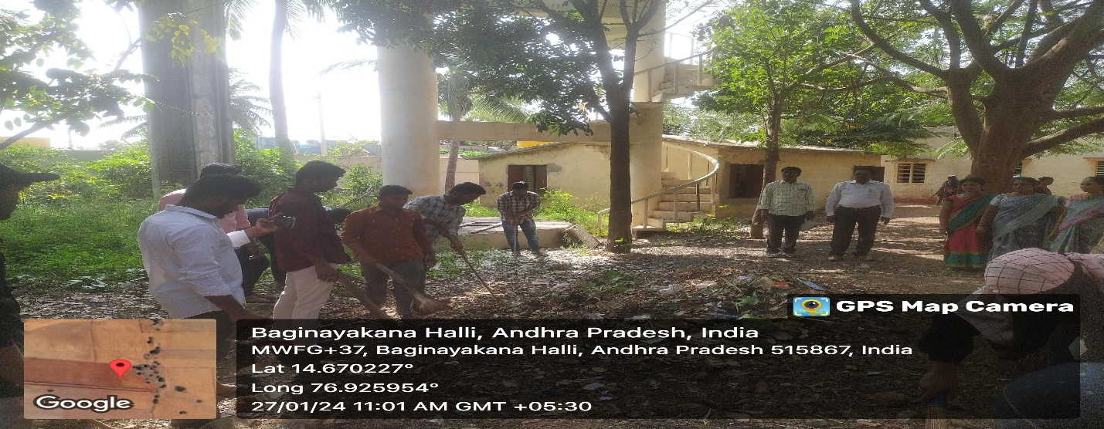
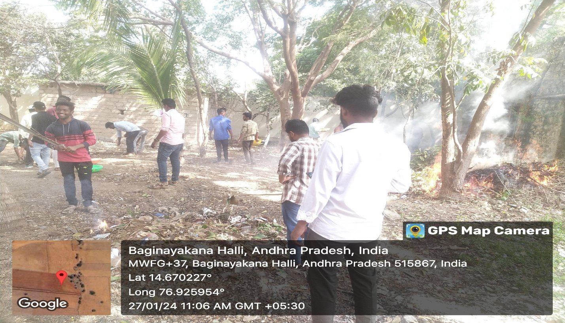

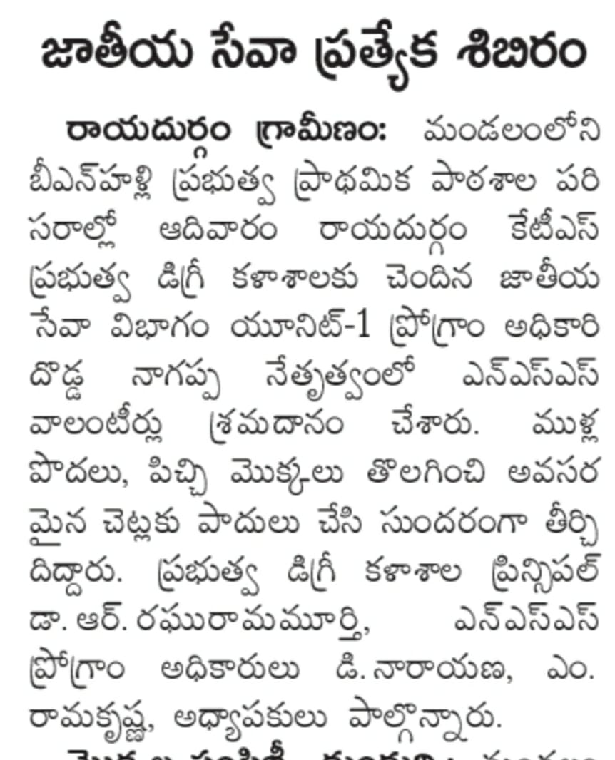

Day 4 :
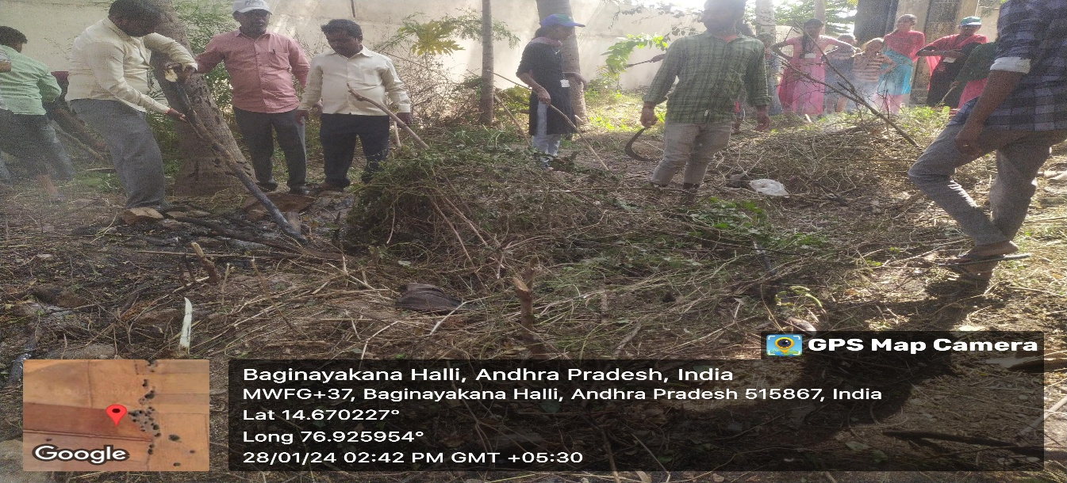
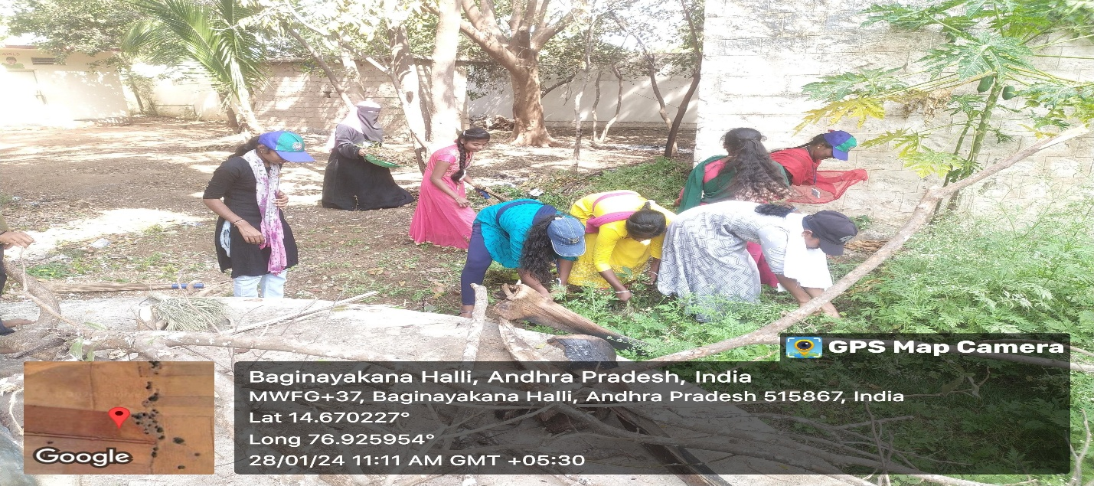
Under the leadership of C. Dodda Nagappa, National Service Department - Unit 1 Program Officer of KTS Government Degree College Rayadurg, Shramadanam was organized in the vicinity of Gram Mandal Primary School as part of the fourth day program of National Service Scheme Seven Days Special Camp at B.N Halli village. On this occasion, the volunteers removed the thorn bushes and wild plants, pruned the necessary trees and beautified them. The village leader Ayyappa, who saw the manner in which the volunteers removed the bushes that had grown too impassable for a long time and made the school surroundings clean, and the people of the village appreciated the efforts of the volunteers. Today the camp was organized by N.S.S. Program Officers D. Narayana, M.Ramakrishna Lecturers Kiran Kumar Pal Raj, Mallikarjuna, Govardhan, Panduranga, Prashanth etc. visited and congratulated the volunteers.

Day 5:
National Service Department of KTS Government Degree College -Unit 1 Program Officer C. Dodda Nagappa led National Service Scheme Seven Day Special Camp at B.N Halli village on the fifth day of the program to create awareness about the Importance of Literacy and Education in the mandal primary school and village. Programs were organized. As part of this, the volunteers gave examples to the students of the school that life will be dark if the students are not literate, that if they do not have education, they will be left far behind in the modern society, and then there is a chance of being cheated even by the intelligent ones. Then they went around the village and told them about the importance of education and the need to study. He informed that rural areas will improve only when people in every household are educated. The volunteers held a rally and raised the awareness of the people by giving slogans like "He who has no education is a strange animal, "Educate well- Change your mindset" "Educate at home- Light the whole village". The headmaster of the school Nagaraju said on this occasion that the volunteers have made the surroundings of the school very beautiful. NSS Program Officer thanked the volunteers. Today, NSS Program Officers D. Narayana, M. Ramakrishna Lecturers Lakshminarayana, Srinivasulu Parisa madam, Kiran Kumar, Pal Raj, Raghu, Mallikarjuna etc, are visited the camp and congratulated the volunteers.
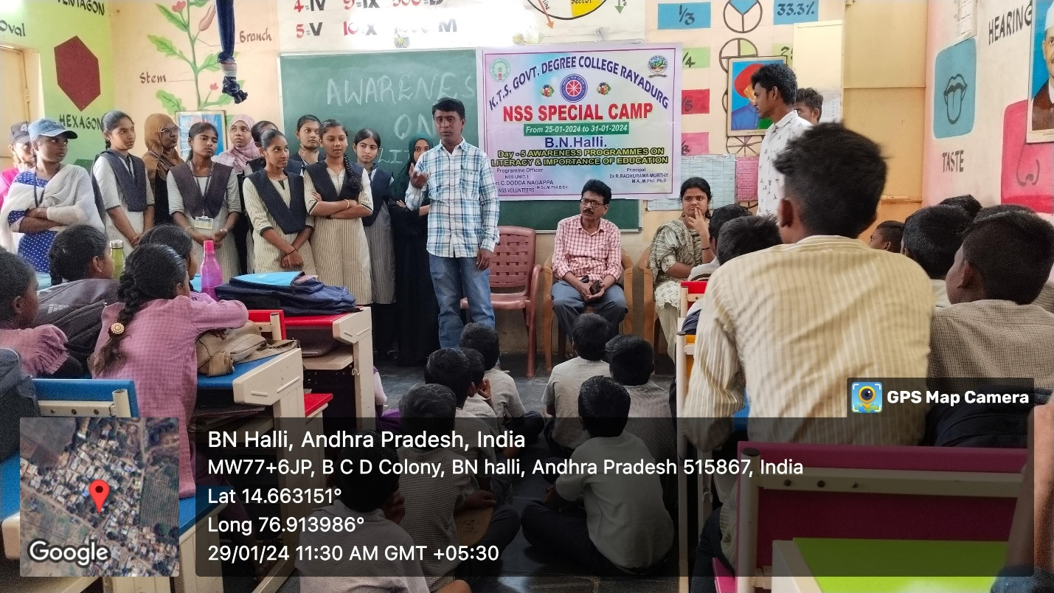

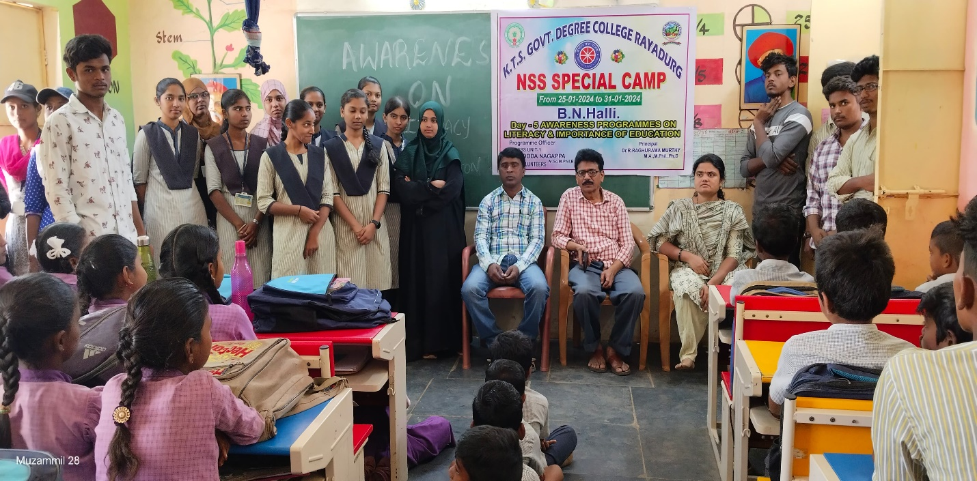

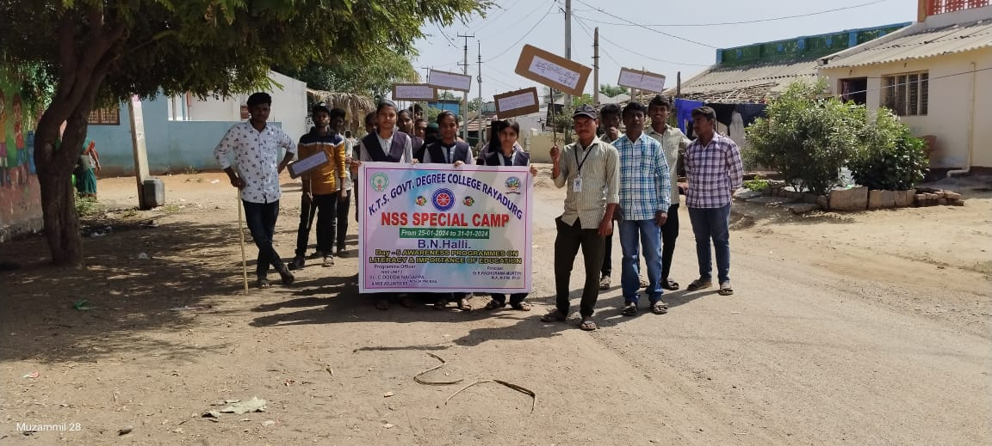
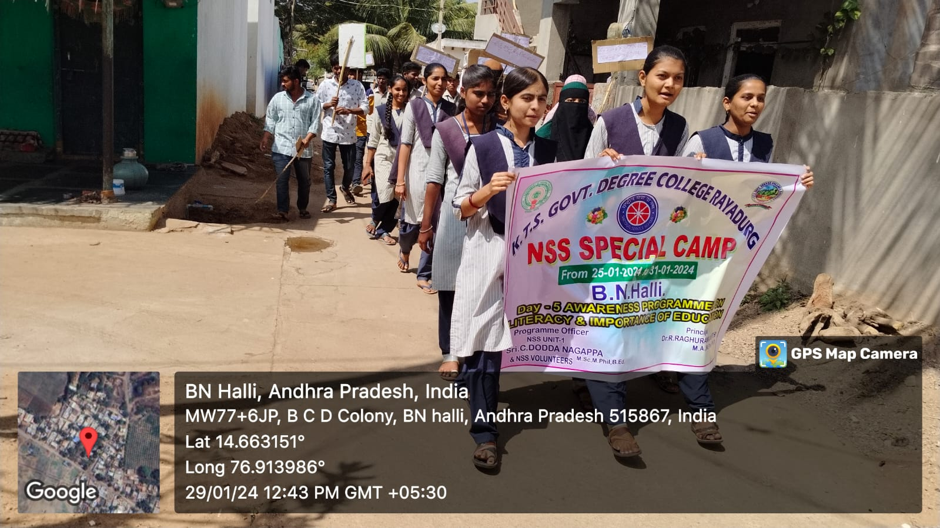

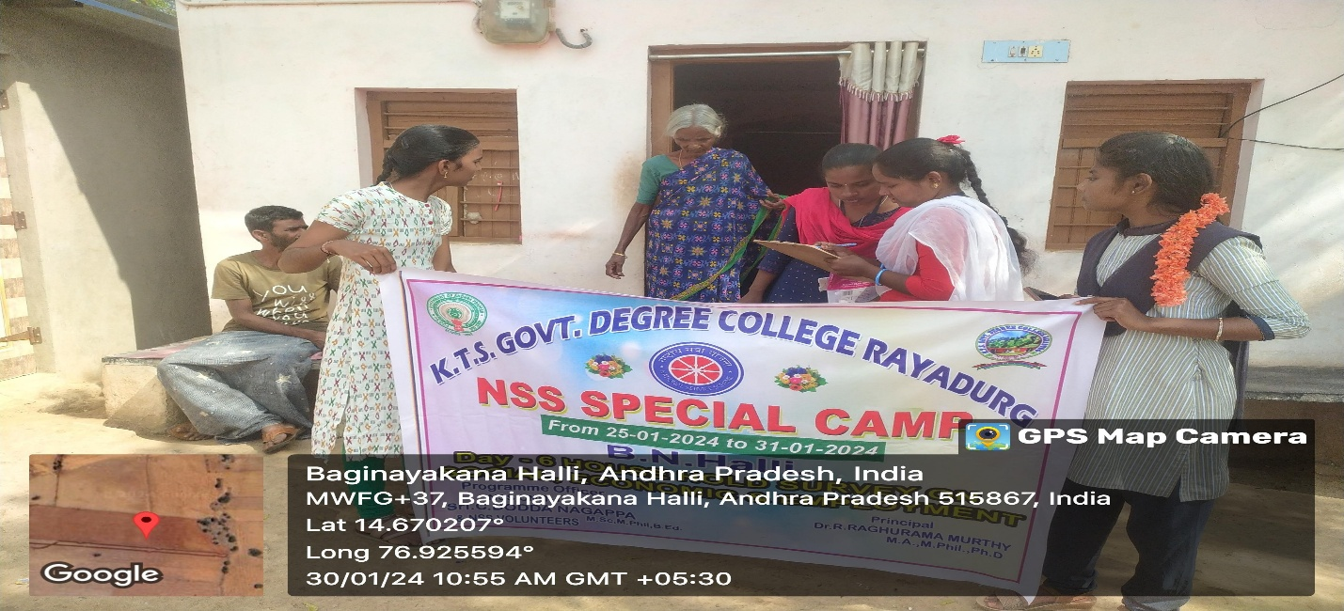
Day 6 :
National Service Department - Unit 1 Program Officer C. Dodda Nagappa of KTS Government Degree College conducted a standardized survey as part of the 6th day program of National Service Scheme seven days special camp at B.N Halli village. As part of this, every house was visited and a survey was conducted on education, income, employment

Social status etc. While there are 340 families in the village, many of the houses were locked because they went to work at the time of the survey. However, volunteers conducted a survey of 152 families in the village. Program officer C. Dodda Nagappa said that a report on this will be prepared and sent to the NSS department of the S.K University. Today, college principal Dr. R. Raghurama Murthy visited the camp and congratulated the volunteers for cleaning the surroundings of the school.
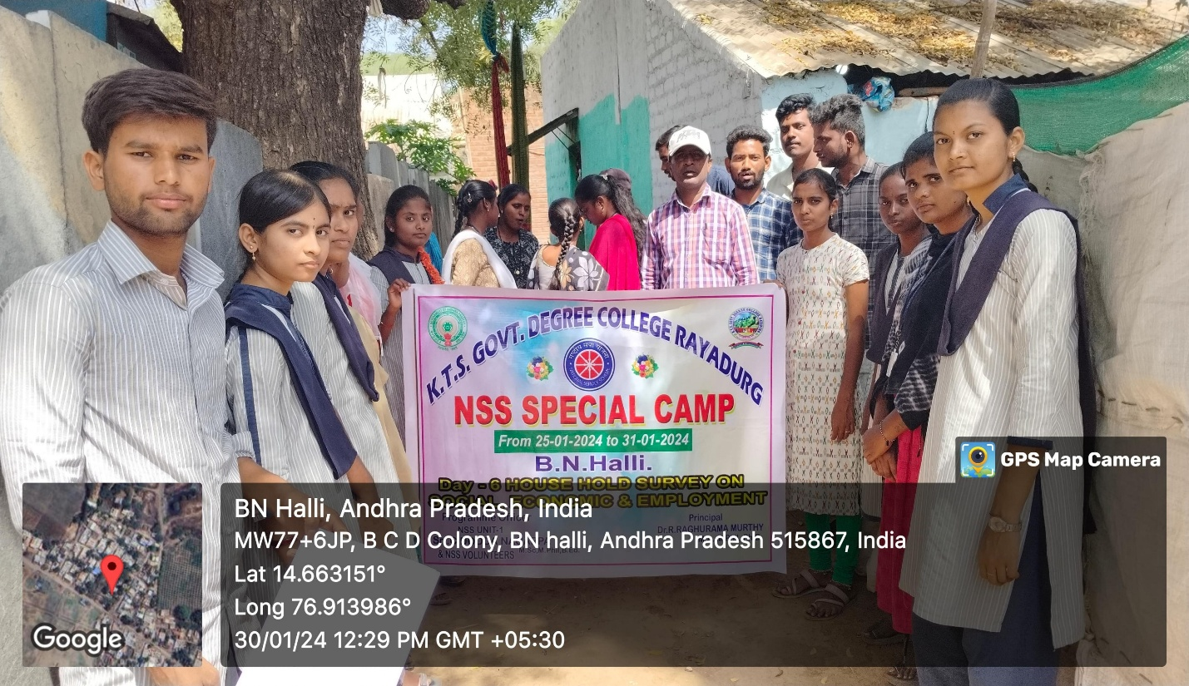

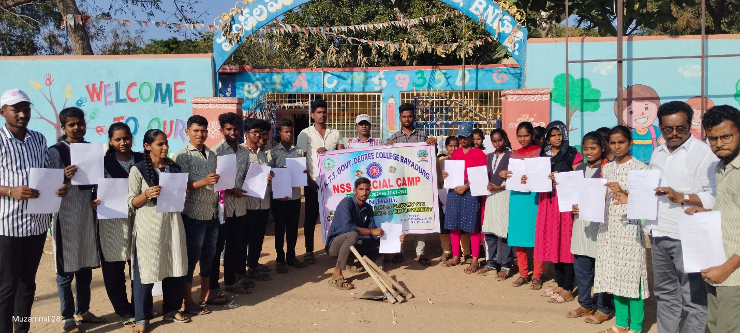

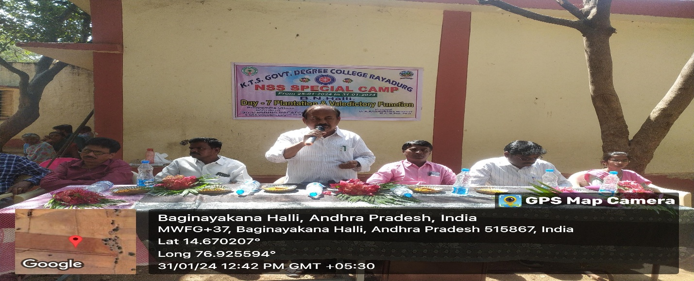
Day 7:
Sapling program and closing program was conducted as part of the 7th day program of National Service Scheme seven day special camp at BN Halli village. As part of this, the volunteers planted saplings in the primary school and then a closing program was organized under the chairmanship of the principal. On this occasion, the principal of the college, Dr. R. Raghurama Murthy, addressed the gathering and said that the seven-day special camp of NSS Unit-1 of the college at Banepalli village was a success. According to the words of the headmaster, the village Program Officer Dodda Nagappa congratulated the NSS volunteers and said that the seven days special camp was organized very well by the volunteers and NSS Program Officer Dodda Nagappa. School Headmaster Nagaraju gave a speech and thanked the volunteers for beautifying the surroundings of the school. Bihanhalli Sarpanch Chandrakala. Gari's husband Ramanjaneyulu gave a speech from the stage and said that the volunteers have been working hard in our village for 7 days to create awareness and sensitize the people, and where it is necessary to remove the thorn trees, bushes, mud and garbage accumulated around the water tank with JCB. Inspired by the work done by the volunteers, he promised to repair the dilapidated room and make it useful for the village. Speaking, Dodanagappa thanked the volunteers who worked tirelessly for the success of the seven-day special camp and thanked the people of the village for their support. NSS Program Officers D. Along with Narayana M. Ramakrishna, teachers Ravikumar, Kiran, NCC cadets, Panchayat Secretary Shobha and others participated.
